Deployment Of App in IBM Cloud

Deploy in Kubernetes Cluster

(Customer Care Registry_PNT2022TMID52279)

Step1: login with ibm.com,search with kubernetes cluster in search catalog

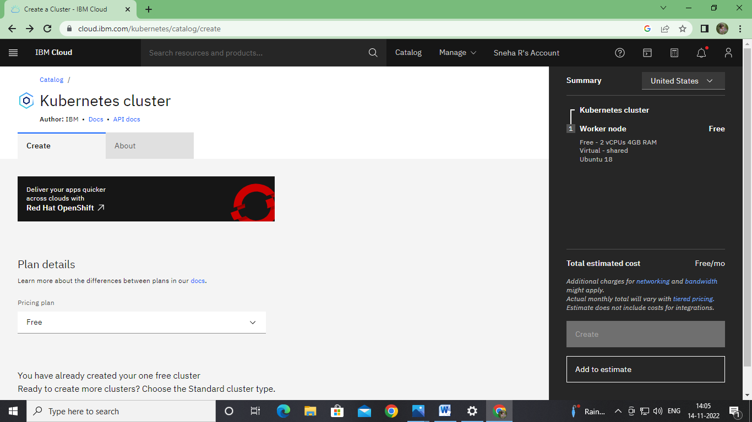

Step 2:

Created kubernetes cluster:

